Task5. Allow-deny statements
Created policy - Allow permission
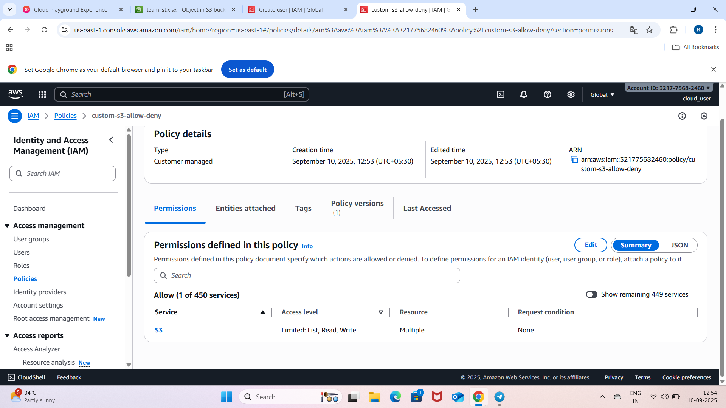
Policy attached to user-myself
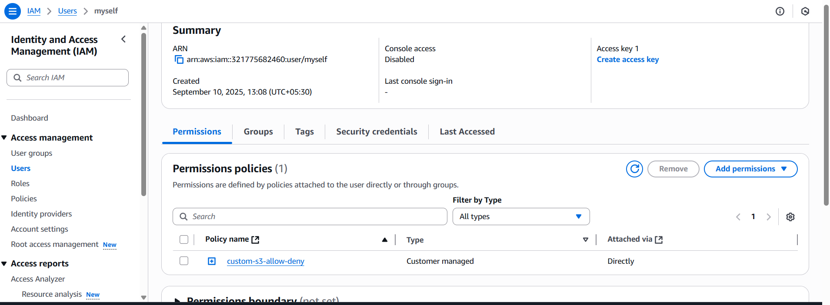

Myself user could list all buckets
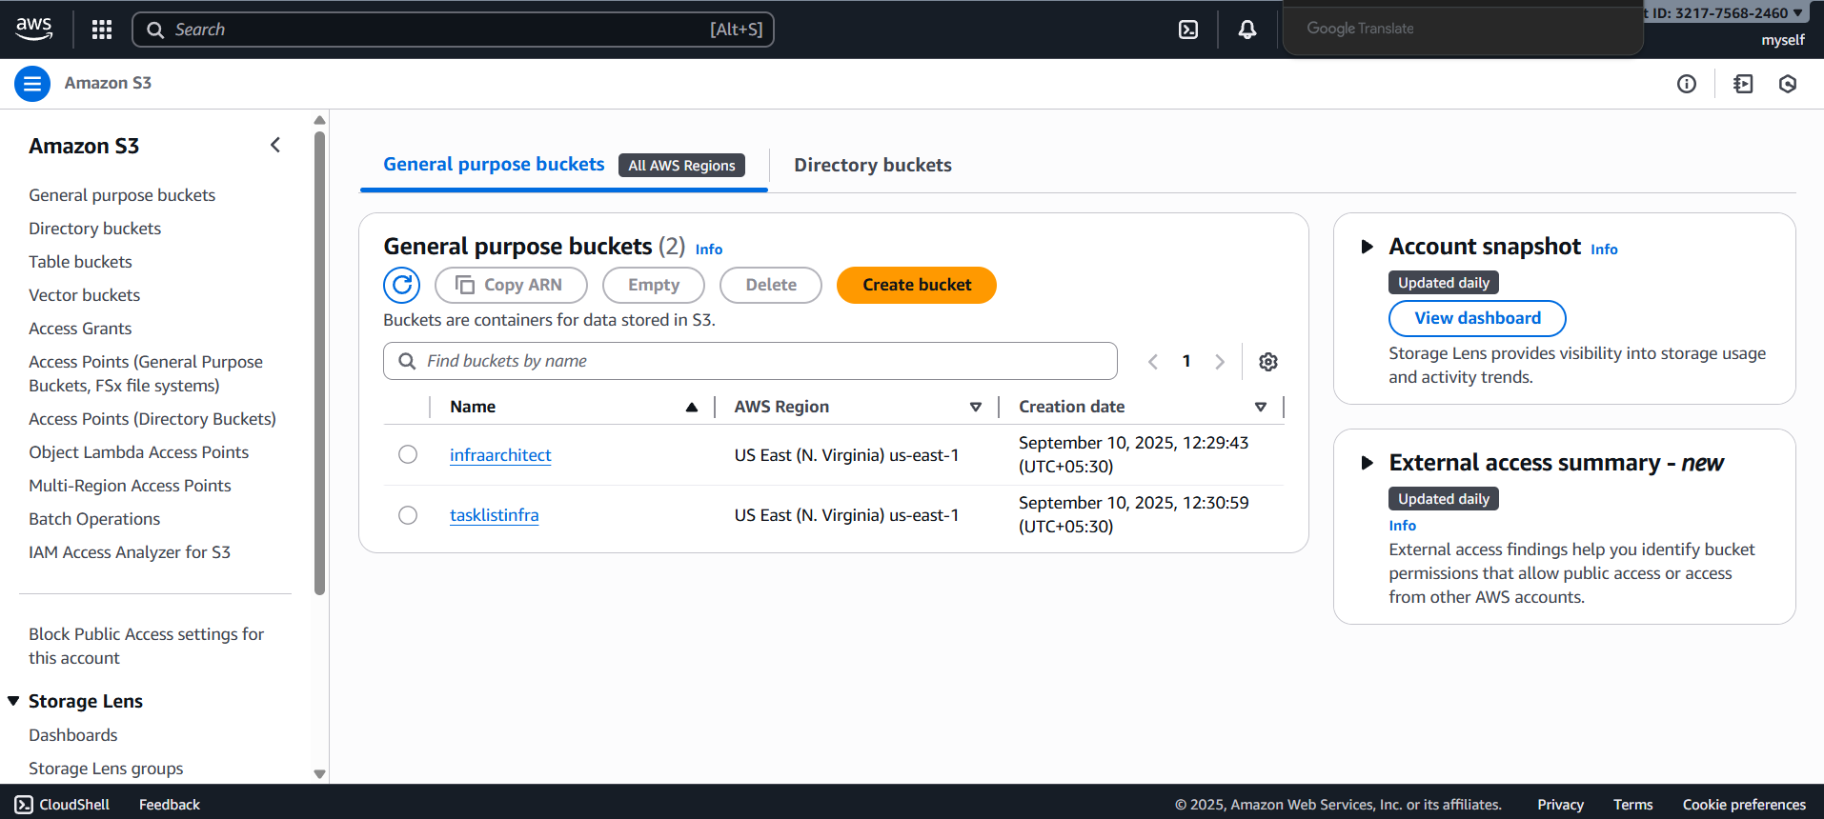
Myself user could upload object, delete and download (put,get,delete) for specific bucket.
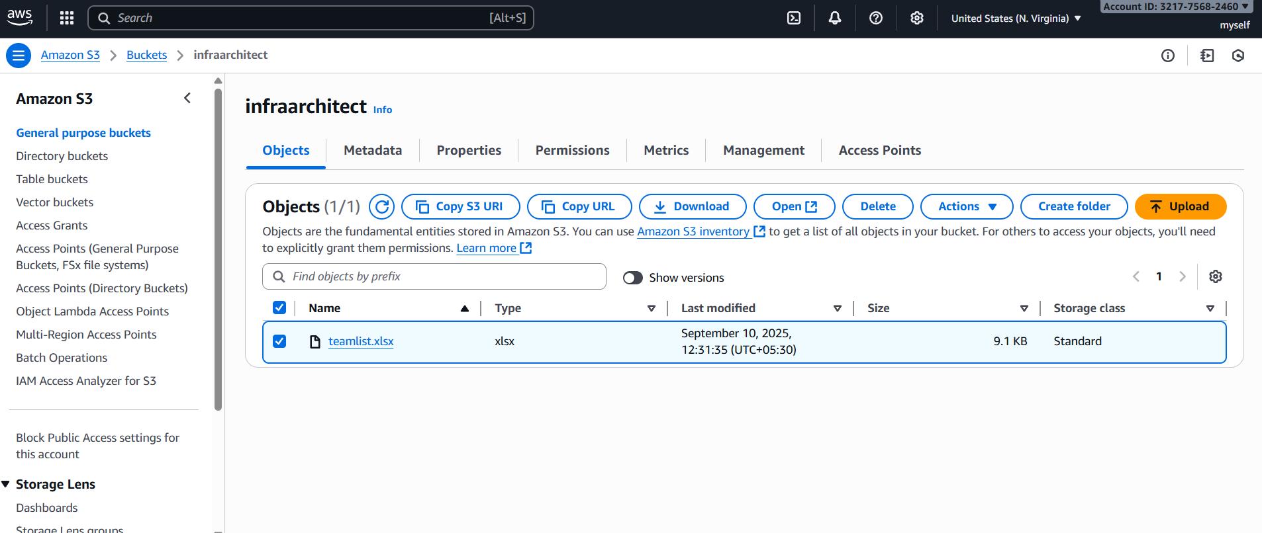
Myself-user couldn’t list object in another bucket which is not specified in permission
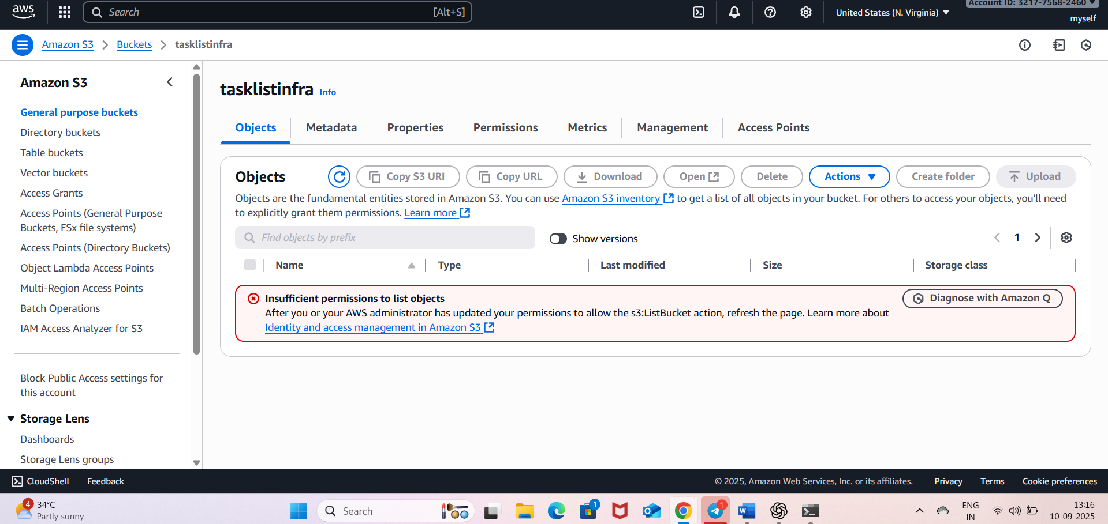
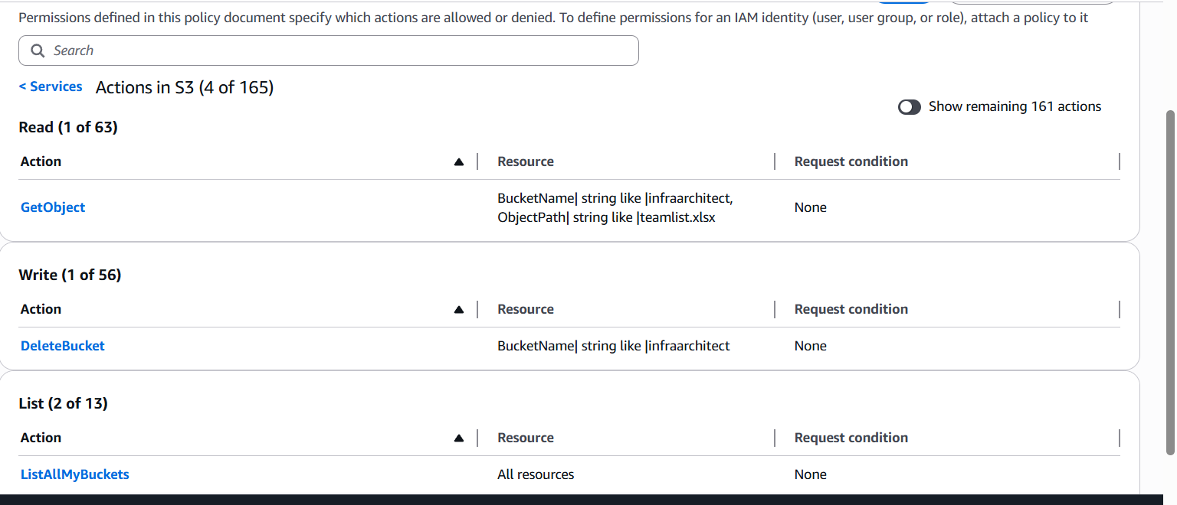
Adding deny statement
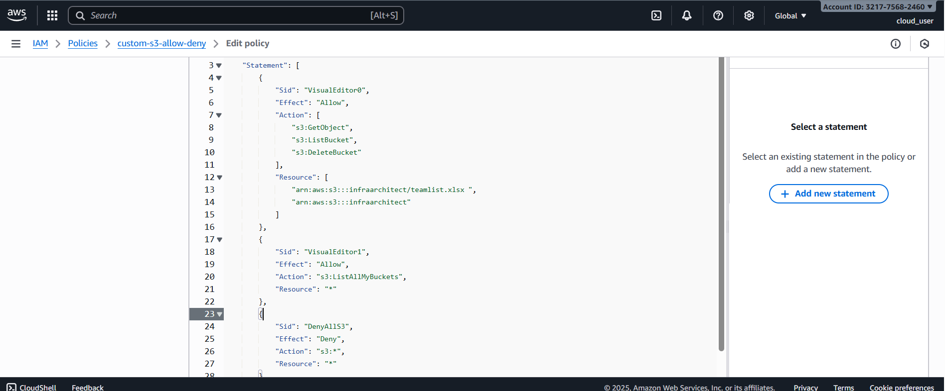
Shows explicit deny and shows empty allow though given in json
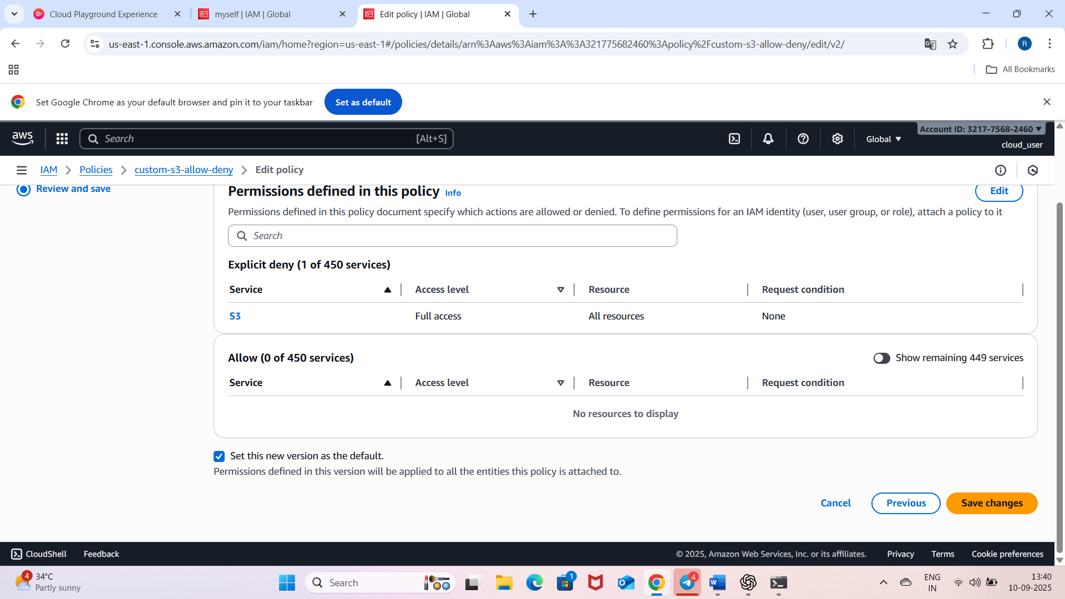
User not able to do action(delete) which is denied.
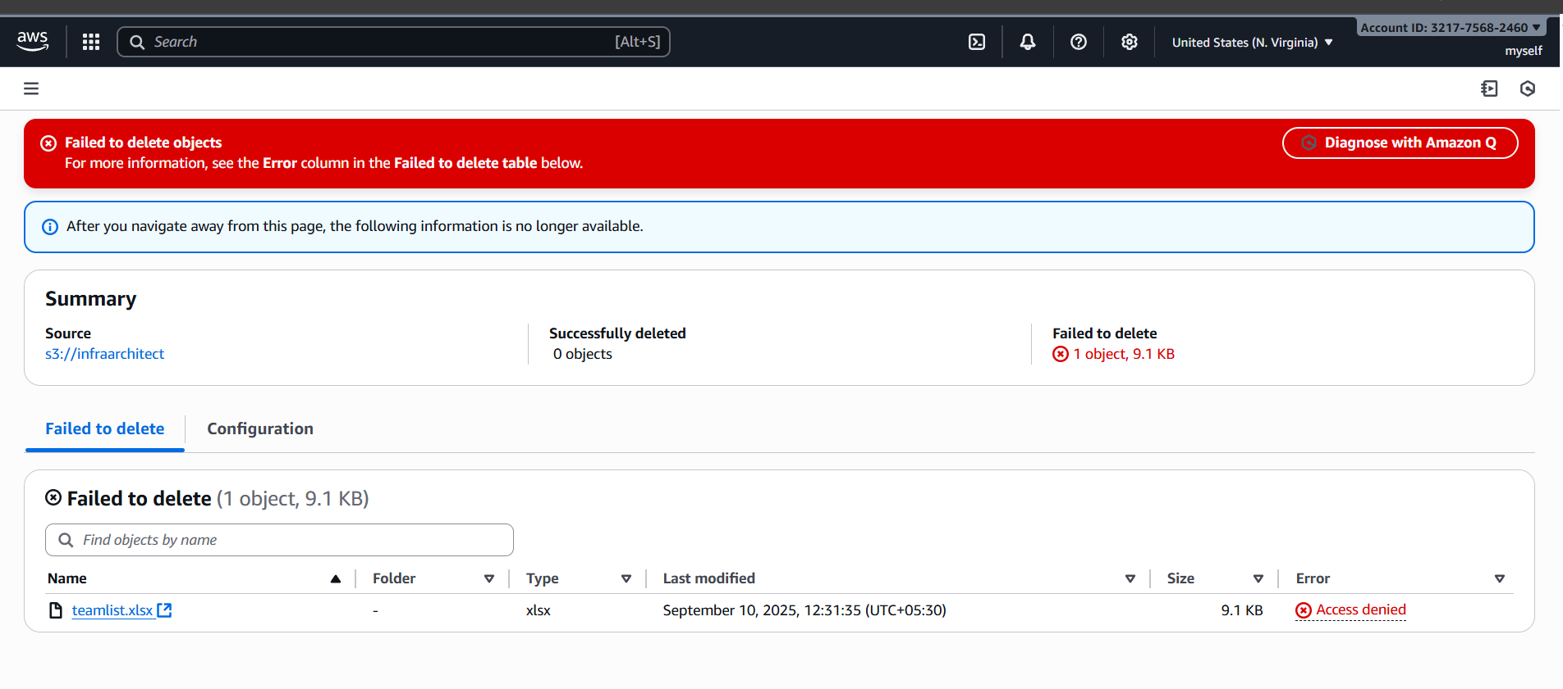
Not able to upload
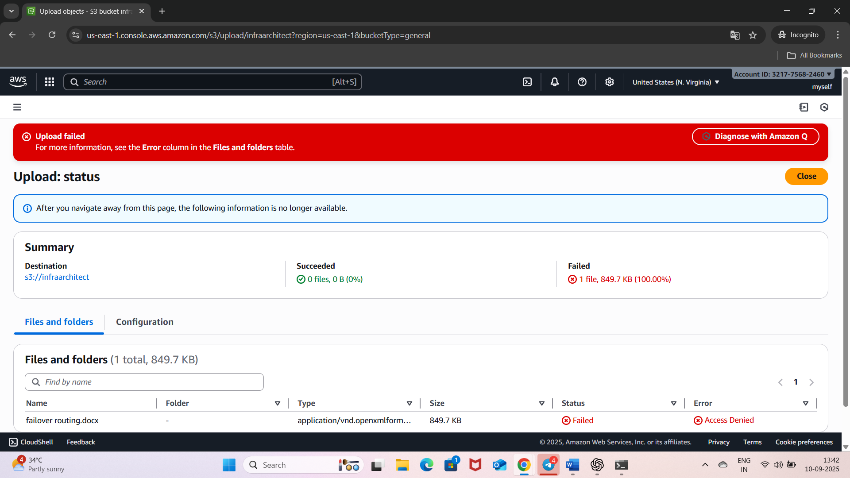

Window shows password change policy
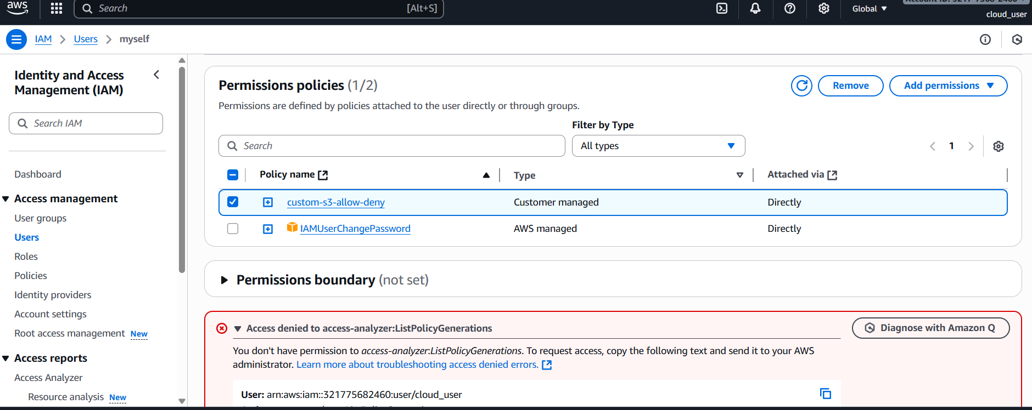
Task2: created custom policy to delete bucket and inline policy for the same user to get object(deluser)
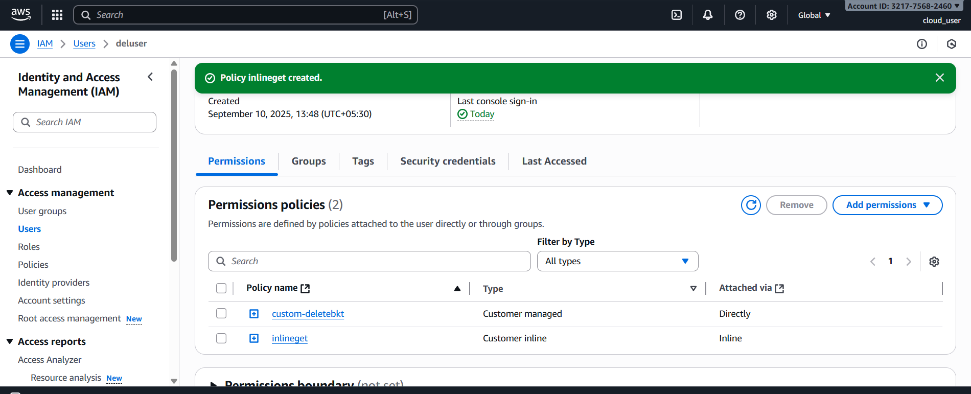

Bucket not empty
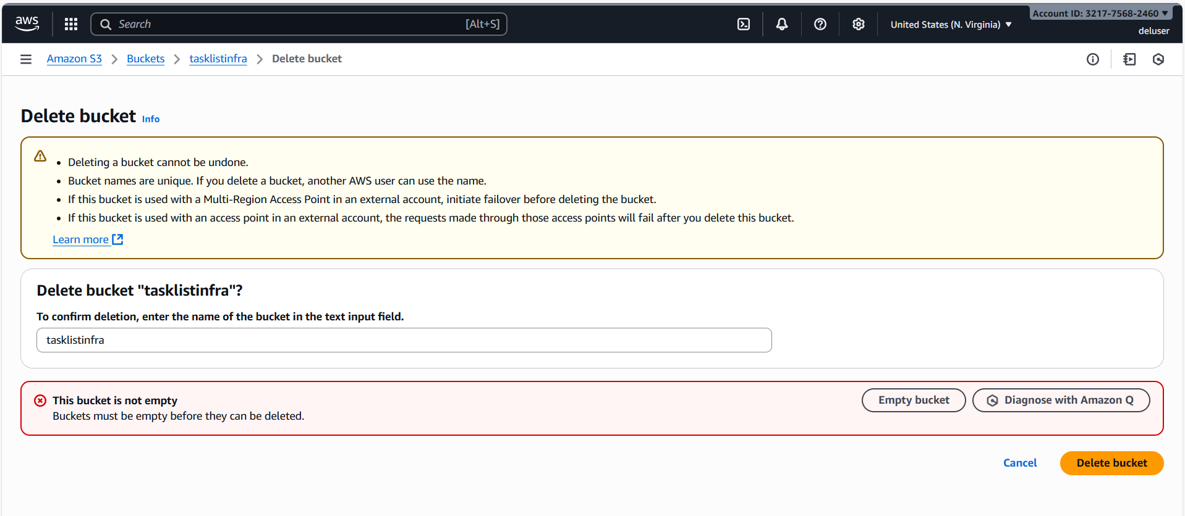
Deluser deleted object
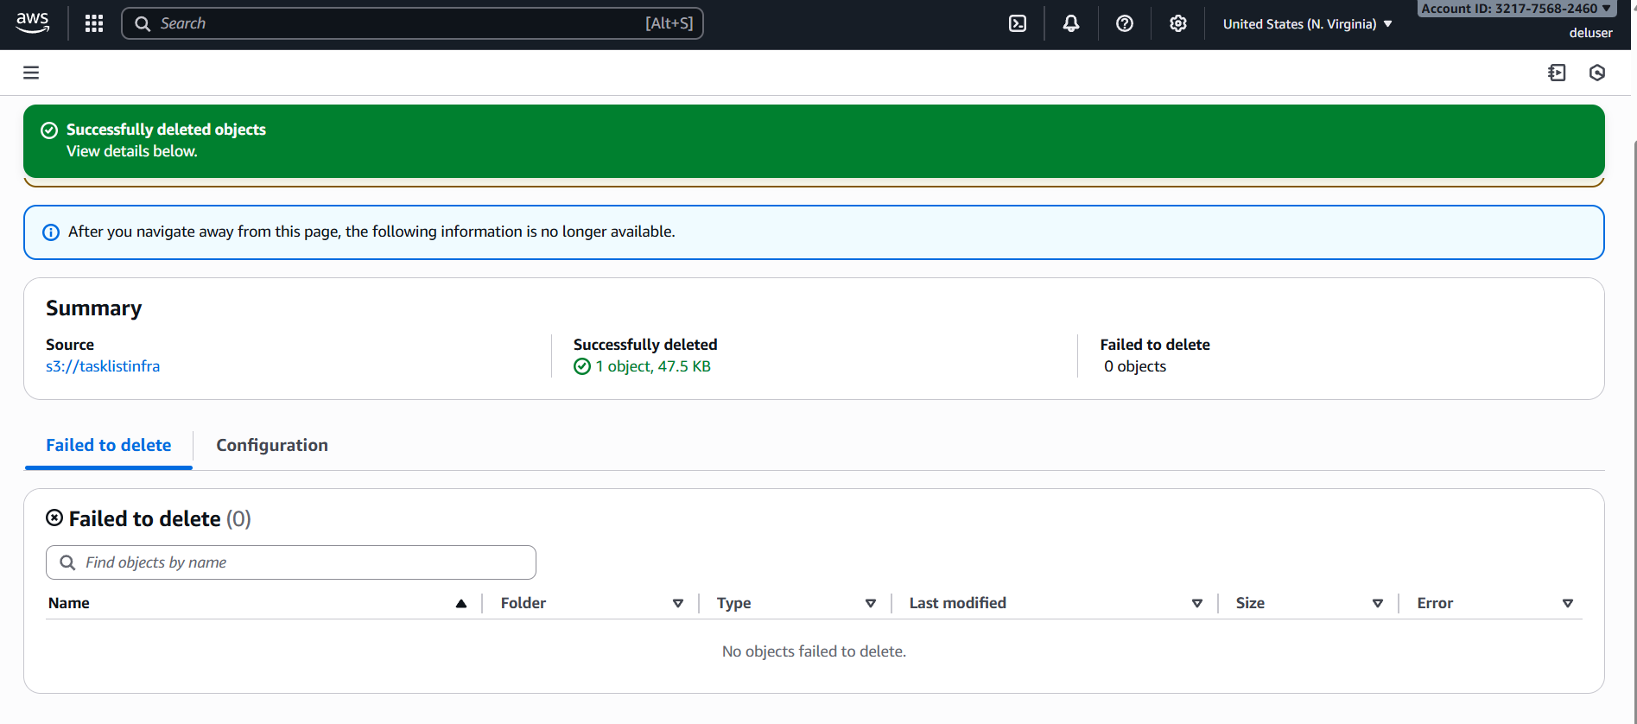
Deluser successfully deleted bucket
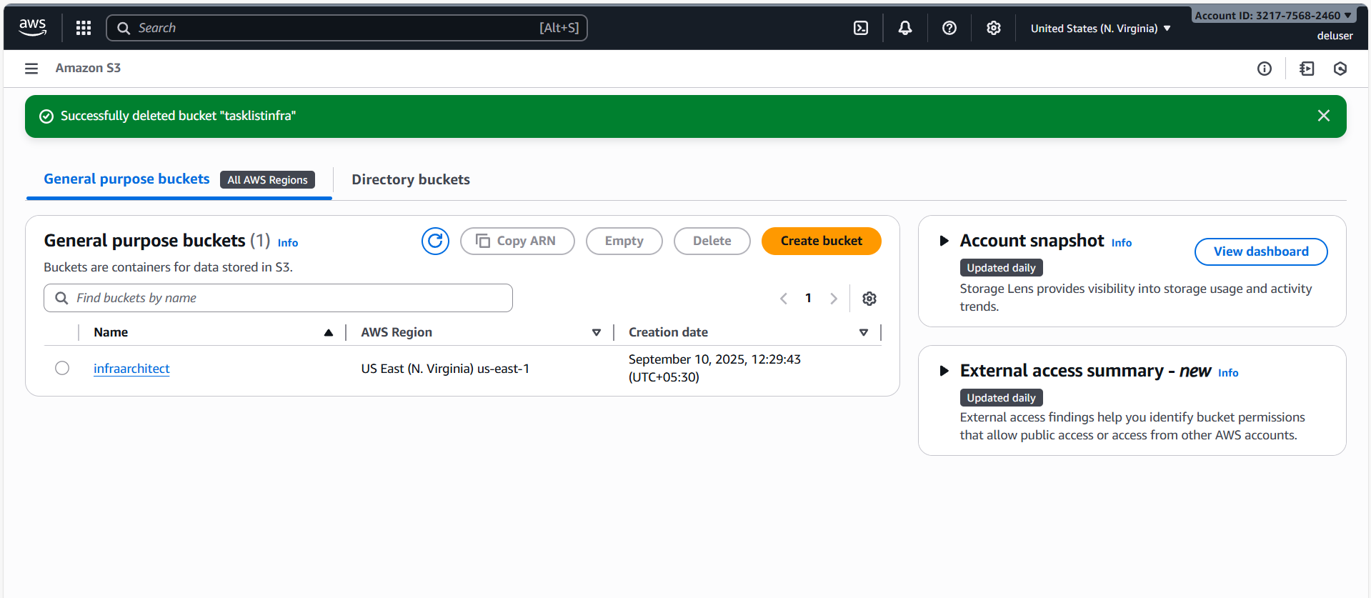

Deluser downloads (get) object (inline policy)
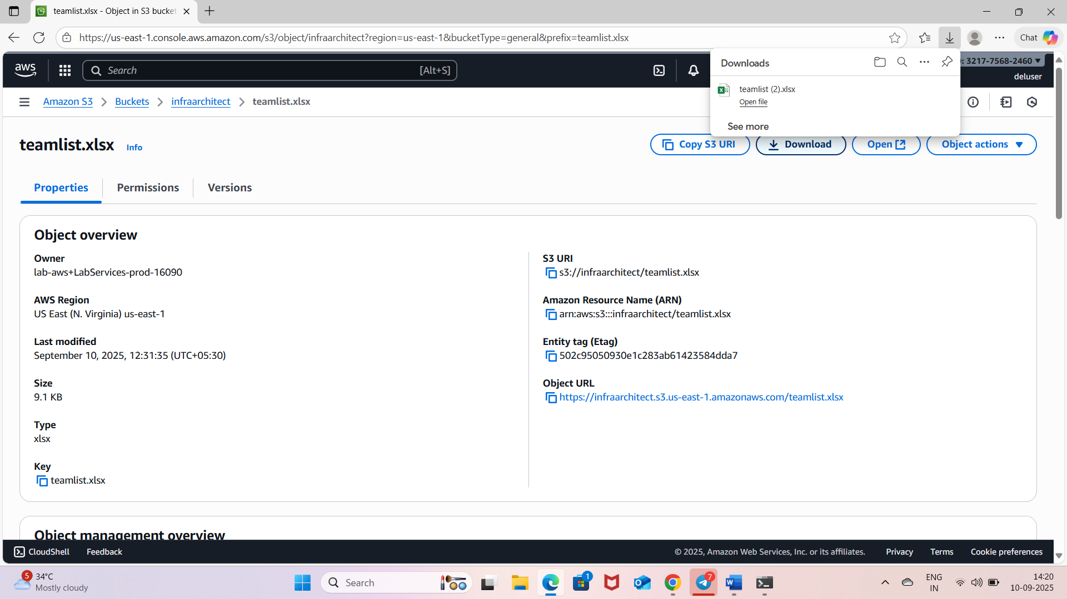

Task3: tested listing bucket, object, download(displays encrypted)
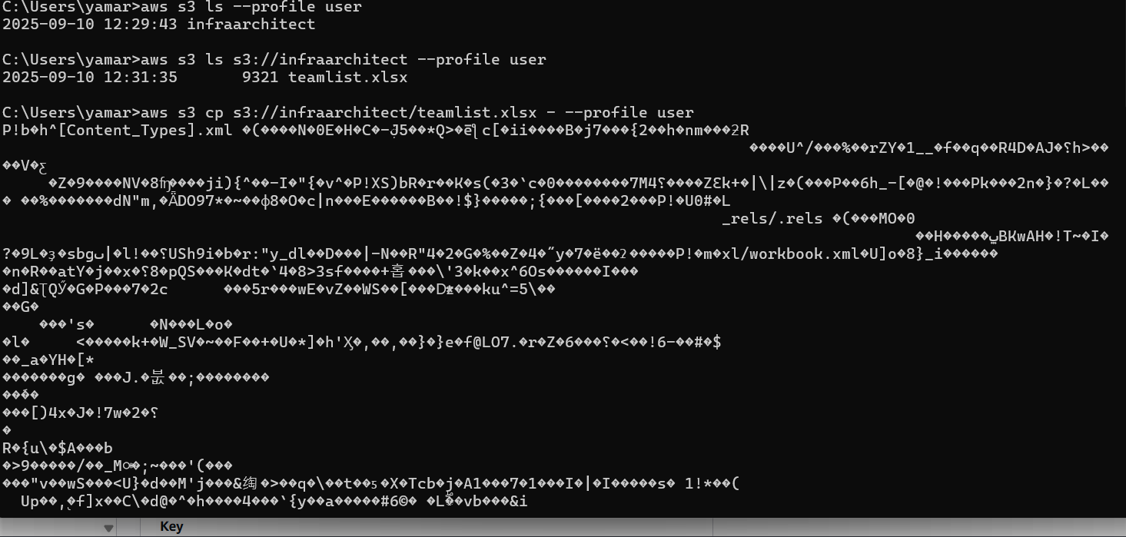
Removed object from another bucket using cmd and deleted bucket
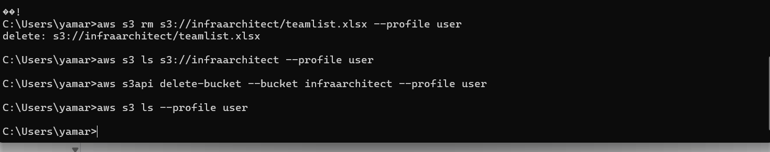

All buckets deleted(empty)
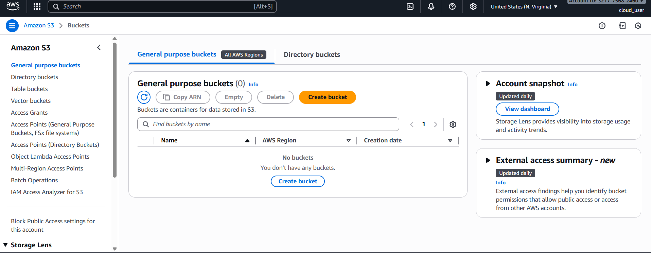
Task4:
Creation ec2-user and attached ec2-creation policy
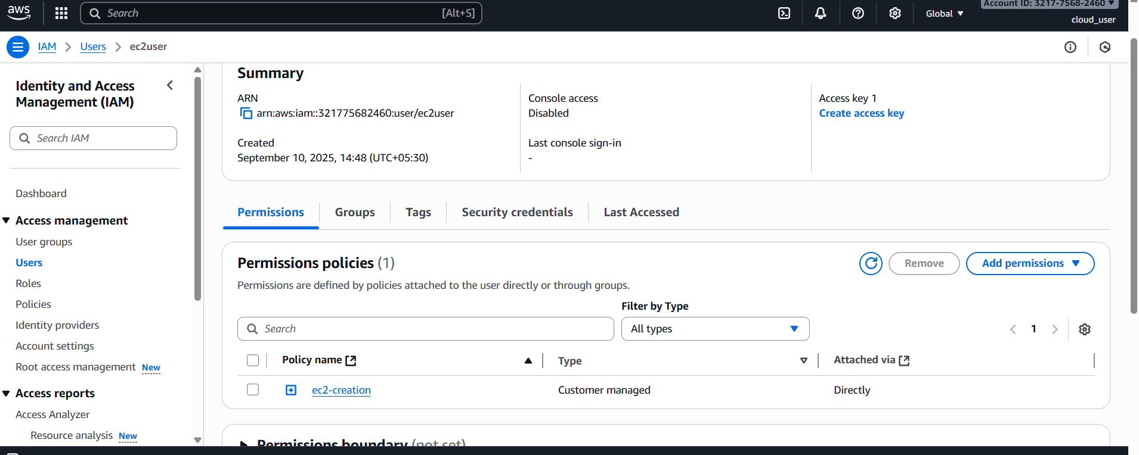

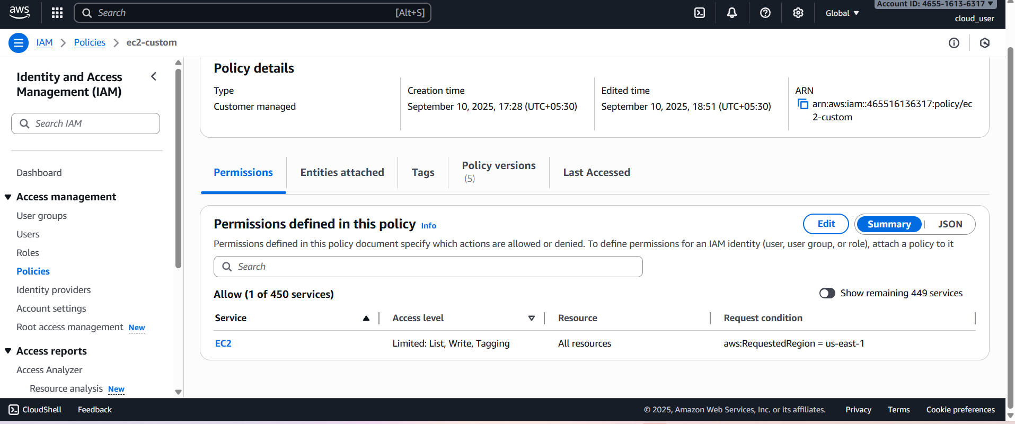

Json format that shows key creation, using ami images from particular region
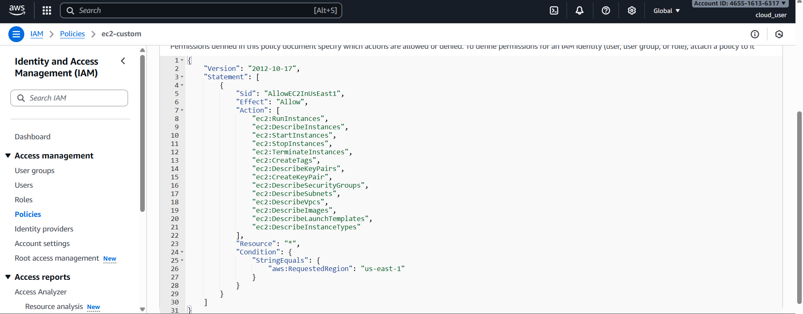
Successfully created EC2

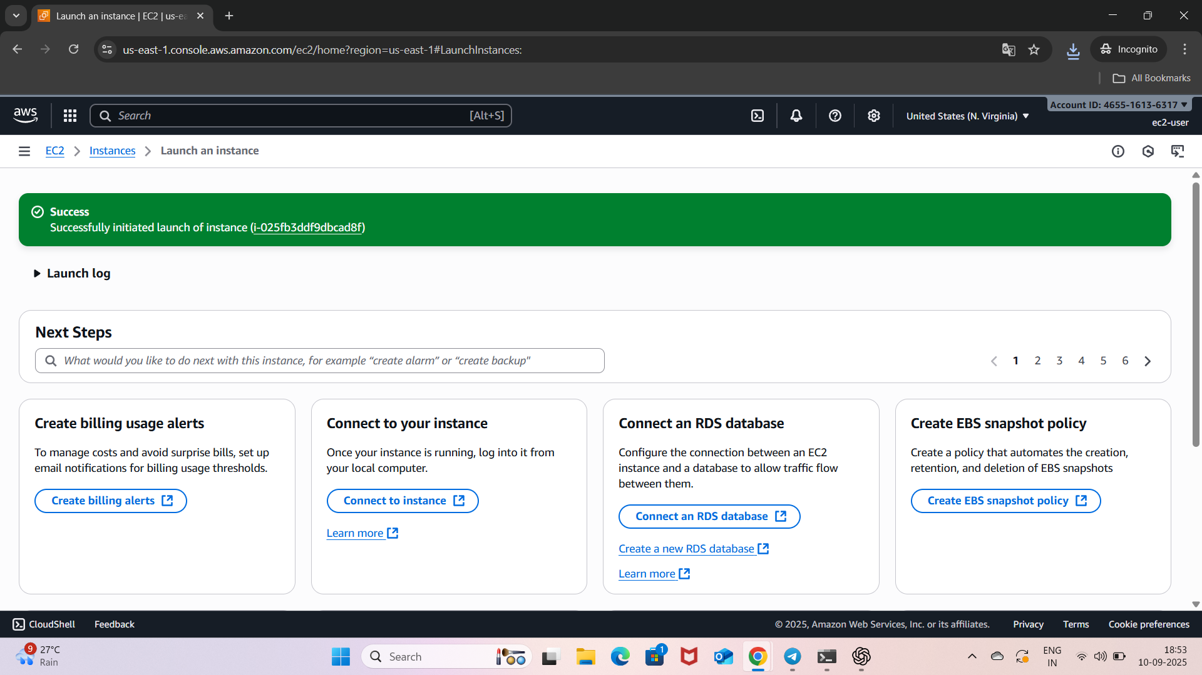

Permission denied for connect.. no public IP..
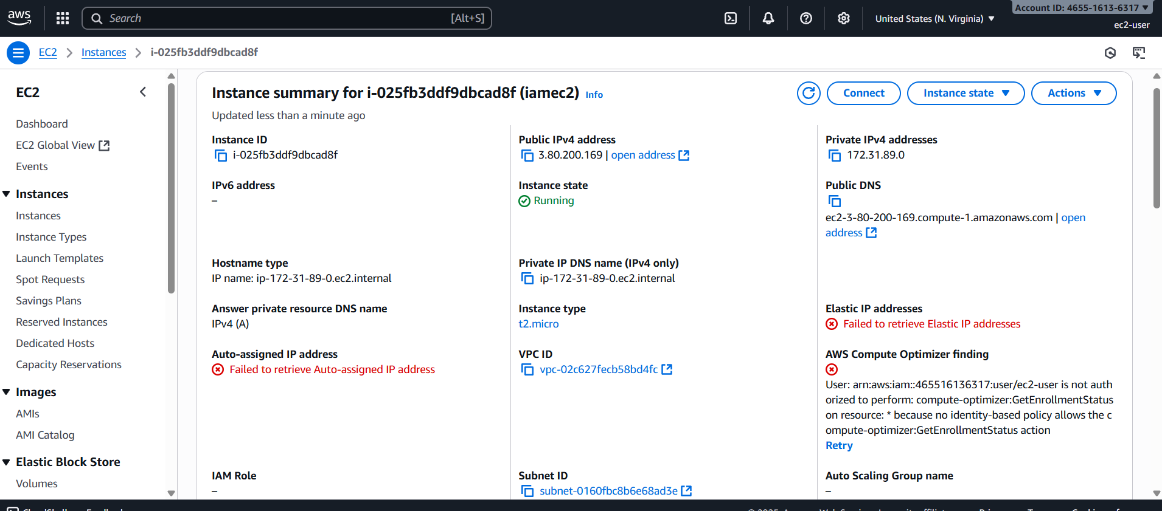
Permission given to stop and terminate
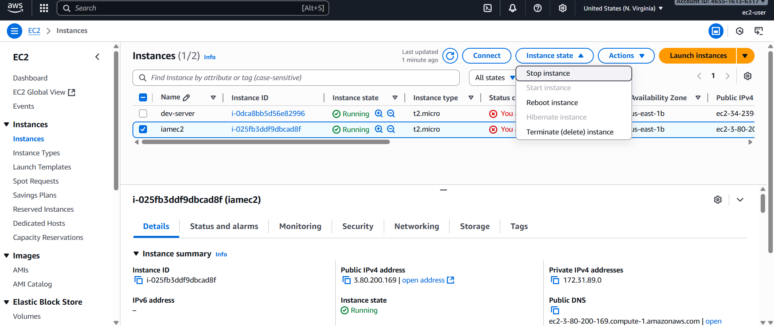

Terminated
